Local Government Area School (LGA) summary analysis

Using the provided data, I have analysed the area wide standardised test results across the LGA schools for maths and reading. The analysis provides a snapshot of the areas schools, the number of students, the current school budget and maths and reading results.

Within the LGA we have a total of 15 schools, of which are both government and independently run schools. The grouped analysis is as follows:

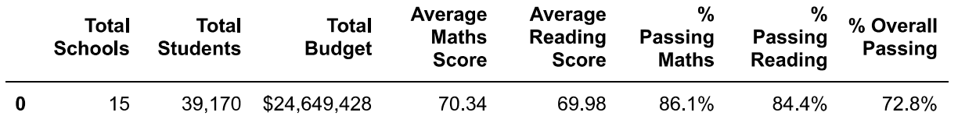

Upon analysis of the individual schools, the top five performing schools are as follows:

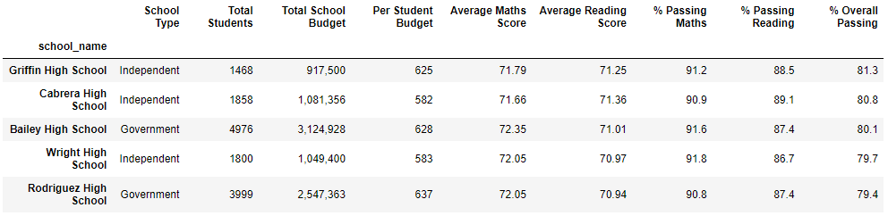

The bottom five performing schools are as follows:

Upon review of the maths and reading scores per grade for each school, the schools appear to have consistent scores across the grades. Generally, students do not have significant, if any, decrease in their scores from grade 9 to 12.

When the data is analysed based on budget per student, number of students or school type we are able to determine that these three factors impact student scores.

The data supports independent schools perform better than the government schools, but the majority of the independent schools have less than 2,000 students per school. The smaller school sizes (less than 1,000 students) have better maths and reading scores than the bigger schools. The schools of this size are two independent schools.

The lowest performing schools have greater than 2000 students with all but one being government schools. There is insufficient data in our analysis to determine if the government schools do not provide the same level of support to the students as the independents, but there is a strong correlation to support smaller schools allow students to perform better.

One would generally assume that the bigger a school’s budget, the greater the maths and reading scores. The data analysis for our LGA does not support this assumption. A budget of $585-$630 per student appears to lead to greater maths and reading scores.